# Weekly Progress Report

## 1. Feasibility Study:

* Reviewed a paper on design, implementation and testing GNSS RTK for high accuracy positioning.
* I researched relevant information by referring to YouTube videos, blogs, and DIY website for other sources of information.

Below tabular column consists of all the relevant links referred for the last week research:-

|  |  |
| --- | --- |
| **Relevant Links** | **Source** |
| Designing and Testing an IoT Low-Cost PPP-RTK Augmented GNSS Location Device | <https://www.mdpi.com/1424-8220/24/2/646> |
| How to Build a DIY GNSS Reference Station | <https://learn.sparkfun.com/tutorials/how-to-build-a-diy-gnss-reference-station/all> |
| How RTK works | Real-Time Kinematic for Precise GNSS Positioning | <https://youtu.be/ieearzWTCZw> |
| Review of PPP–RTK: achievements, challenges, and opportunities | https://satellite-navigation.springeropen .com/articles/10.1186/s43020-022-00089-9 |

Below contains the set of hardware needed for setting up our own GNSS RTK base station along with the overall price that is needed.

Other available sources online

Readily available source minimal setting up required.

This model is what the below one’s used and demonstrated

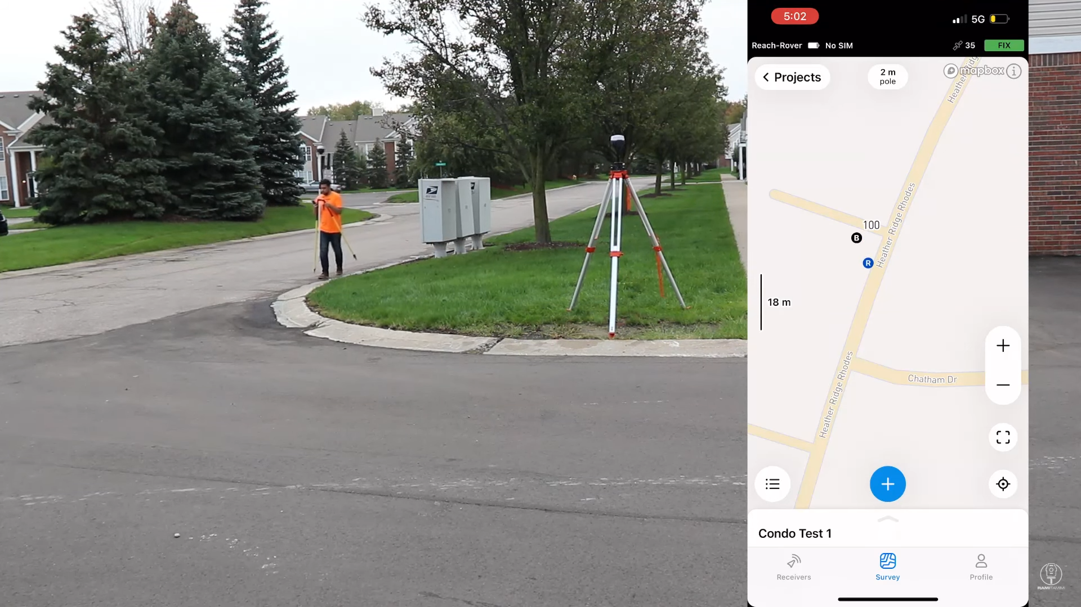

This [video](https://youtu.be/Rk09oMD_I24) has used the same above stated GNSS RTK and demonstrated the setting up process.

How is it going to look like in real world implementation.

Conclusion:

* Going with the DIY is the most probable option, since the overall price could be within $2000.
* On the other hand, buying the version that the video demonstrates could reduce the setting up cost drastically, but the price would increase drastically too.
* We need to get expertise on setting up the GNSS RTK from the DIY website.

## 2. MATLAB Simulation of GNSS:

* MATLAB does contain 'gpsSensor' and 'gnssSensor' objects for simulating the GPS and GNSS receivers virtually.
* But how realistically it could incorporate the inaccuracies in the measurements is still needs to research. From my findings, these outputs are in general ideal values and might not be taken as a simulation tools.

## 3. SolidWorks design for the receiver and rover:

Rover design

* Sketched a simple design of the rover 30x30x15 cm to understand if the sensors could fit on top of the rover.

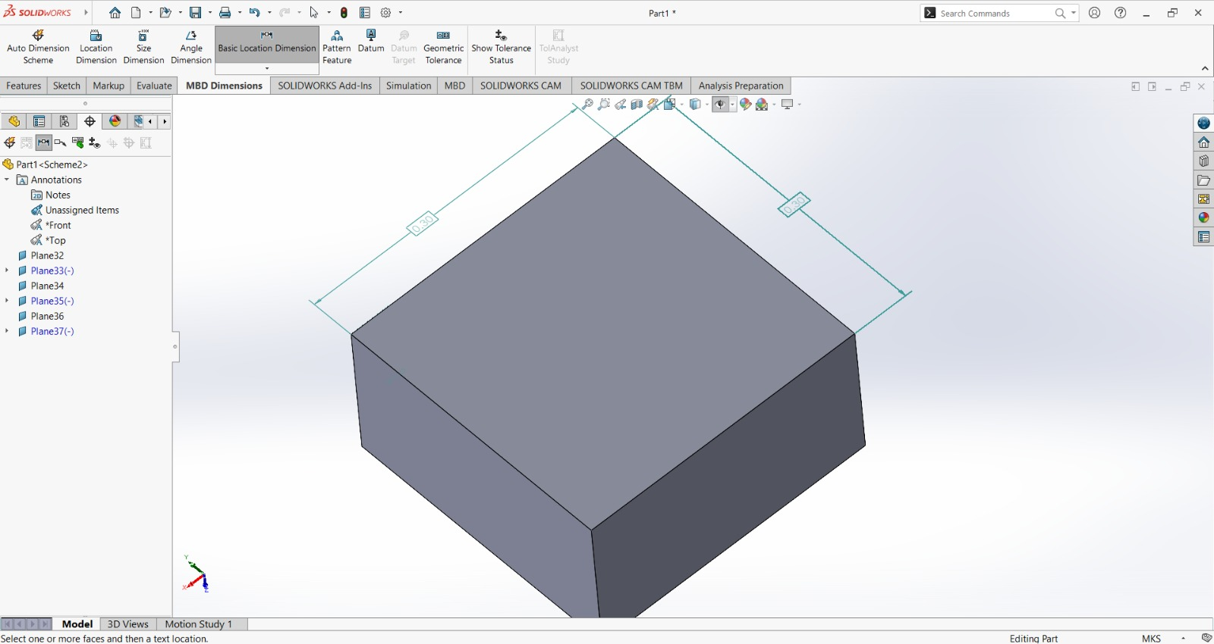

Sensor design:

* The DIY website gave an RTK receiver that was costlier and was not coated and ready for the rovers.
* Found this [version](https://www.amazon.com/BTuregsau-Dual-Band-High-Precision-Satellite-Navigation/dp/B0DFQ8HG8Z/ref=sr_1_39?crid=14KK5WYPRO0FE&dib=eyJ2IjoiMSJ9.utqhfEazSvR_rx-TLzHMK-eVddrfu5Bhjl6Q5SAOUtH5Y-W9g5ObfBZqt6Oyti_R7PvENByGVZJoq3XTuibaO5Ku5ZayPg1nwX3qwHXPl8oim9ufYRiKuyA8L4surLMp7QLHGPhQI2H98VRCJdOmfT-H8l6QPrdgiFNRWkHL8Hn2JATKjxEW8s6JAdoKJRJW.ImO11NgTrOPzInJ1zYINucSFY78f_glJO-SYPhNrXIo&dib_tag=se&keywords=gnss+rtk+receiver&qid=1729054852&sprefix=gnss+rtk+re%2Caps%2C187&sr=8-39) of GNSS receiver online which was compact and was compatible for the UAVs too and especially way cheaper.

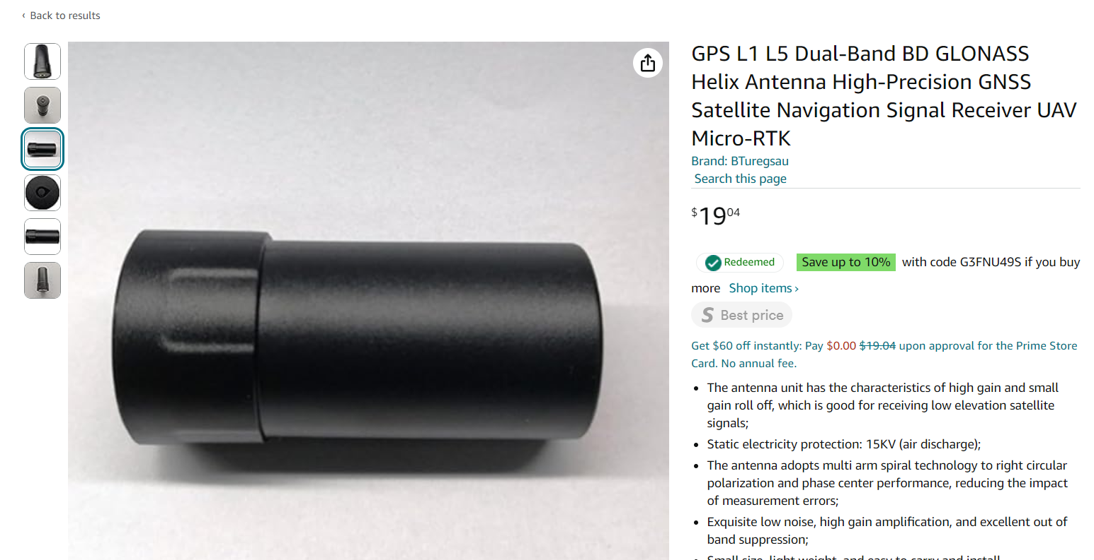

Sensor design in SolidWorks

Assembly of the sensor to the rover

Sensor design:

* The DIY website gave an RTK receiver that was costlier and was not coated and ready for the rovers.
* Found this [version](https://www.amazon.com/SparkFun-GPS-RTK-SMA-Breakout-ZED-F9P-Concurrent-dimensional/dp/B087T7BV6K/ref=sr_1_2?dib=eyJ2IjoiMSJ9.320FnQ3xDjf27lHJbie8kqc1Y3JD_3qKHTvl_h-n--Tj-nwRgn8YPH4lZq00fMdLXzUrhqXkL4UCWNvIrjhtjhA7FCtubiwtKkxOsNPQVa-VG-llWEhbfeaUz7RaaaK5lTW6Z68QAg1qzCBFuuCv5_bwslktH02riVPPzUMA64Oes_O-z1ih6pAZBylTXtO7gtmZVMEVxdj6TNHBWkCdmUlrMVY_2DGBagvkuTbfsEI.6kRPIpycaMc0HAiM7ZtCNZpptfgA4L9QRVQ5aTJo3mc&dib_tag=se&hvadid=695413705639&hvdev=c&hvexpln=67&hvlocphy=9030087&hvnetw=g&hvocijid=11107242743742255837--&hvqmt=b&hvrand=11107242743742255837&hvtargid=kwd-836696285664&hydadcr=15787_13677515&keywords=zed-f9p&qid=1730261363&sr=8-2) of GNSS receiver online which was compact and was compatible for the UAVs too and especially way cheaper.

3D LIDAR Sensor design in SolidWorks

Assembly of the sensor to the rover

4. MATLAB Simulation:

Setting Farmland in MATLAB

* + Opened MATLAB and began by setting up the simulation environment for creating farmland.
  + Created a 100x100 meter grid using the meshgrid function, which generates 2D arrays X and Y representing the coordinates of your field.
  + To create a realistic base terrain, utilized a combination of sine and cosine functions with different frequencies and amplitudes.
  + Added random variations using the randn function and applied a Gaussian filter with imgaussfilt to smooth the terrain, creating a more natural-looking surface.

Rover imported to the Farmland MATLAB environment

* The overall design of the agriculture rover we finalized is of the shape of a cuboid with dimensions 30x30x15 cm.
* Hence used the patch function of the MATLAB and initialized necessary vertices and faces to match the above mentioned dimensions.
* The with the patch function displayed the simulation element of the agriculture rover onto the MATLAB simulation environment.
* Then imported the rover object onto the already created farmland created in the MATLAB simulation environment.
* Created the base to simulate the agriculture robot on to the simulated farmland environment, going forward we can start implementing the agricultural processes.

5. Next Steps:

* + - Get feedback on what is the potential direction for next week of research and if simulation is the direction we need to proceed.
    - Look for other cheaper options available in the market for setting up the GNSS receiver and the antenna base.
    - Look for other simulations available for GNSS RTK.
    - Improve the design of the SolidWorks better for next time.